Fix Run Can not find Spring boot

This error on the complier- I using JRE 25 and it can not find it for complier
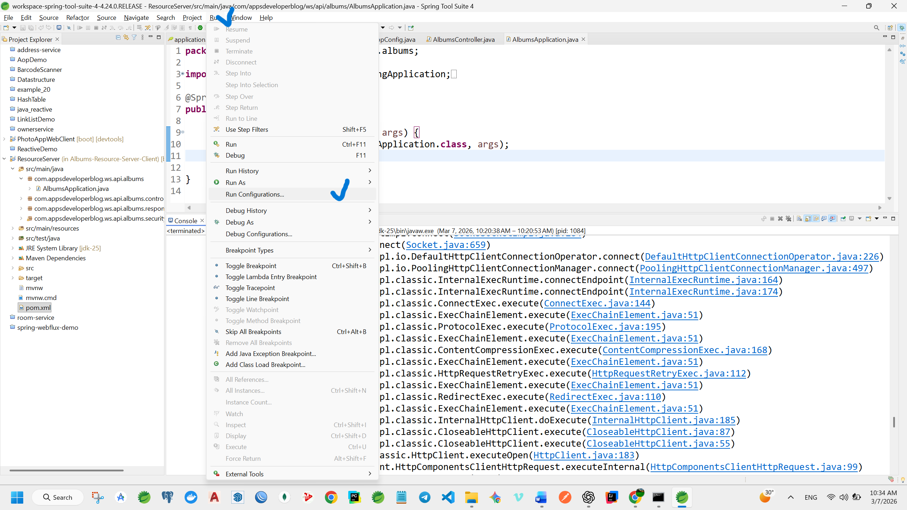

Issue on:
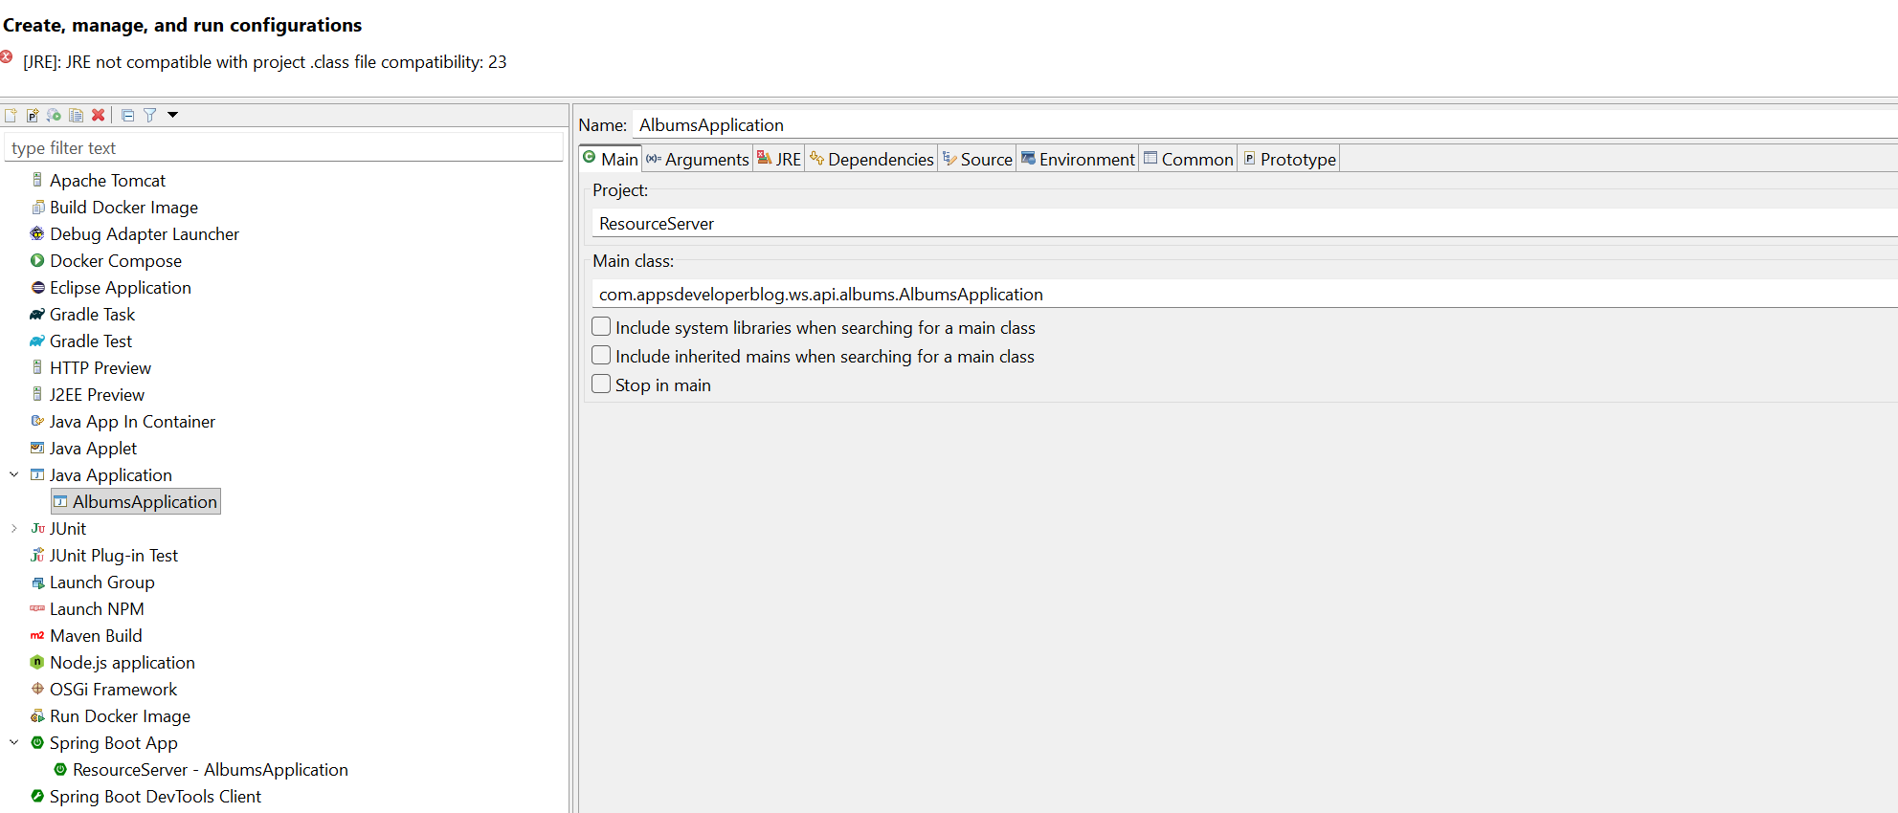

Solution :
Keep only what is the JDK- We need the app to run
